**Listify ‑ Task Manager App**

**A PROJECT REPORT**

***Submitted by***

**RUDRA PATEL**

**210800107033**

***In partial fulfilment for the award of the degree of***

**BACHELOR OF ENGINEERING**

***in***

**Computer Engineering**

**Vadodara Institute of Engineering, Vadodara**

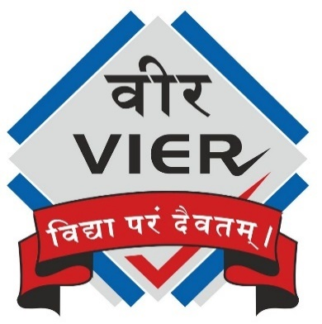

**Gujarat Technological University, Ahmedabad**

**[June 2024 - July 2024]**

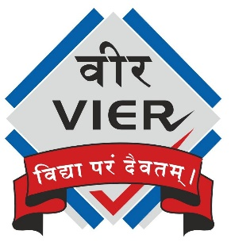

**VADODARA INSTITUTE OF ENGINEERING**

**KOTAMBI, VADODARA**

**CERTIFICATE**

This is to certify that the project report submitted along with the project entitled **Listify ‑ Task Manager App** has been carried out by **Rudra Patel (210800107033)** under my guidance in partial fulfilment for the degree of Bachelor of Engineering in Computer Engineering 7th Semester of Gujarat Technological University, Ahmedabad during the academic year 2024-25.

**Prof. Pratik Kahar**

Internal Guide

**Prof. Jemisha Patel**

Head of the Department



**VADODARA INSTITUTE OF ENGINEERING**

**KOTAMBI, VADODARA**

**DECLARATION**

We hereby declare that the project report submitted along with the project entitled **Listify ‑ Task Manager App** submitted in partial fulfilment for the degree of Bachelor of Engineering in Computer Engineering to Gujarat Technological University, Ahmedabad, is a bonafide record of original project work carried out by me at **Navodita Infotech** under the supervision of **Parul Saxena (HR Executive)** and that no part of this report has been directly copied from any student’s reports or taken from any other source, without providing due reference.

**Rudra Patel**

Name of the Student

Signature of Student

**OFFER LETTER**

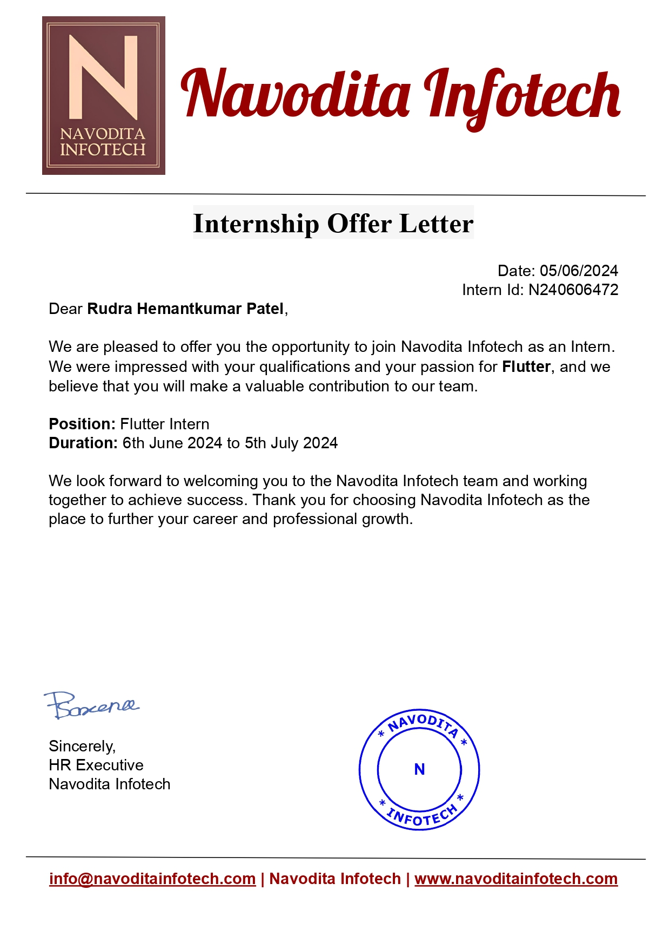

**CERTIFICATE**

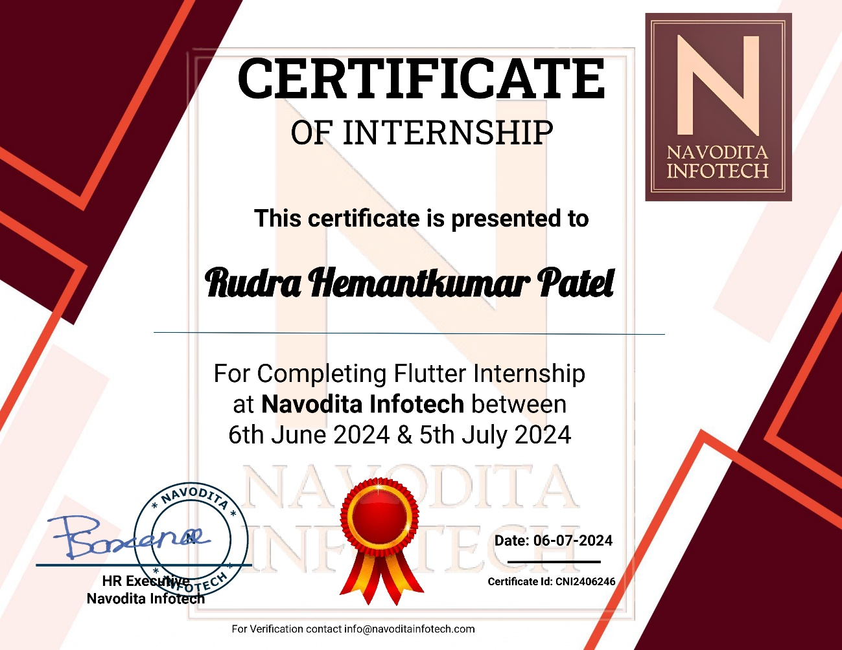

# ACKNOWLEDGEMENT

I am very thankful for giving me the opportunity to undertake my internship training at the **Navodita Infotech**. It was a very good learning experience for me to have at this site.

First, I would like to thank Head of The Department **Prof. Jemisha Patel** of Vadodara Institute of Engineering for giving permission to commence this Internship.

Further, I would like to express my sincere gratitude to my Industrial Mentor **Parul Saxena** for continuously guiding me at the company and solve all my doubts with patience. Also, I am very obliged to my Internal Guide **Prof. Pratik Kahar** for helping me throughout my internship and giving me necessary suggestions and advices along with their valuable coordination. Without their continuous support it would not have been possible to complete my internship.

# ABSTRACT

The Internship project titled **Listify – Task Manager App** is a project developed under the summer internship program. It is developed using the **Flutter framework** and **Dart** as its programming language.

A task manager app serves as a comprehensive tool for organizing and tracking tasks and projects. It allows users to create tasks, assign them to specific categories, and set deadlines, making it easier to manage both personal and professional responsibilities. With features like reminders and notifications, users are prompted to complete tasks on time, helping to minimize procrastination and keep projects on schedule. The app’s interface is typically designed to be user-friendly, offering a clean and intuitive layout for easy navigation.

In addition to basic task management, many task manager apps offer advanced features such as progress tracking and priority setting. Users can mark tasks as complete, monitor their progress through visual indicators, and set priorities to focus on the most important tasks first. This helps in better time management and ensures that critical tasks are addressed promptly. Some apps also provide analytics and reporting tools, offering insights into productivity trends and helping users optimize their workflows.

# LIST OF FIGURES

Fig 3.1 : Installing Flutter Extension in VS Code 8

Fig 3.2 : Installing Android Platform Tools in Android Studio 9

Fig 3.3 : Starting the Android Emulator 10

Fig 4.1 : Application Homepage 14

Fig 4.2 : Task Input/Edit Bottom Modal Sheet with a Date Picker 15

Fig 4.3 : Mark Tasks as Important or Delete Task by Swiping Left 16

Fig 4.4 : Create, Edit Or Delete Multiple Lists 17

Fig 4.5 : Tasks In All Tasks Section 18

# TABLE OF CONTENTS

ACKNOWLEDGEMENT i

ABSTRACT ii

LIST OF FIGURES iii

TABLE OF CONTENTS iv

CHAPTER - 1 : INTRODUCTION 1

1.1 ABOUT THE INTERNSHIP 1

1.2 OBJECTIVES OF INTERNSHIP 1

1.3 DAILY TASKS AND RESPONSIBILITIES 1

CHAPTER - 2 : COMPANY OVERVIEW 2

2.1 INTRODUCTION TO THE COMPANY 2

2.2 ABOUT NAVODITA INFOTECH 2

2.3 CONTACT DETAILS 2

2.4 SERVICES 3

CHAPTER - 3 : INTERNSHIP ACTIVITY 4

3.1 INTRODUCTION TO FLUTTER AND DART 4

3.1.1 What Is Flutter? 4

3.1.2 Features Of Flutter And Dart 4

3.2 WIDGETS IN FLUTTER 5

3.2.1 What Are Widgets? 5

3.2.2 Most Commonly Used Widgets 5

3.3 STATELESS VS STATEFUL WIDGET 7

3.4 SETTING UP VS CODE AND ANDROID EMULATOR 8

3.4.1 Configuring Visual Studio Code 8

3.4.2 Setting-up Android Development Environment 9

3.4.3 Run The Android Emulator 10

CHAPTER - 4 : BUILDING PROJECT 11

4.1 OVERVIEW 11

4.1.1 Key Features 11

4.1.2 Use Cases 12

4.1.3 Implementation Technologies 12

4.2 DESIGN AND ARCHITECTURE 13

4.2.1 System Architecture 13

4.2.2 User Interface Design 13

4.2.3 State Management 13

4.2.4 Data Management 13

4.3 APP DEMONSTRATION 14

4.3.1 Homepage 14

4.3.2 Task Input And Edit Screen 15

4.3.3 Delete Or Mark Task As Important 16

4.3.4 Create, Edit Or Delete Multiple Lists 17

4.3.5 See Tasks Of All Lists In All Tasks Section 18

4.4 FUTURE UPGRADES 19

4.4.1 Storing User Data To A Database Using Firebase And Firestore 19

4.4.2 Adding Functionality To Work In Teams Or Groups 19

4.4.3 Assigning Tasks To Team Members 19

4.4.4 Creating And Deleting Groups Or Teams 20

4.4.5 Making Someone A Team Leader 20

4.4.6 Adding A Login And Signup Page 21

4.4.7 Using Cloud Database For Data Security And Better Data Persistence 21

CONCLUSION 22

REFERENCES 23

# CHAPTER - 1 : INTRODUCTION

## 1.1 ABOUT THE INTERNSHIP

The Flutter Application Development Internship is a hands-on program focused on building multi-platform mobile applications using the Flutter framework. Interns gain experience in coding, designing, and deploying apps for various platforms, all from a single codebase. The internship emphasizes creating responsive, user-friendly applications with high performance. Throughout the internship, participants work on real-world projects, collaborating with experienced developers and designers. They are involved in tasks such as coding, debugging, and testing, gaining practical skills in the entire app development process. This collaborative environment helps interns develop essential problem-solving and teamwork skills.

The program also includes learning to address client feedback and making necessary adjustments to the applications. By the end of the internship, interns will have developed a portfolio showcasing their ability to create polished, efficient applications, equipping them for future roles in mobile app development.

## 1.2 OBJECTIVES OF INTERNSHIP

Objective of this Flutter Application Development Internship is to create and design user-friendly, responsive, natively compiled and multi-platform mobile applications for clients. This involves delivering applications that provide a seamless and bug-free user experience, ensuring high-quality performance and accessibility across different devices and operating systems. The goal is to enhance our skills in mobile app development using Flutter while contributing to real-world projects that meet client requirements and industry standards.

## 1.3 DAILY TASKS AND RESPONSIBILITIES

During the Flutter Application Development Internship, daily tasks and responsibilities include coding and developing mobile applications, fixing bugs, collaborating with team members, designing user interfaces, enhancing skills, documenting work, and interacting with clients when necessary. The focus is on delivering high-quality, user-friendly, and responsive applications.

# CHAPTER - 2 : COMPANY OVERVIEW

## 2.1 INTRODUCTION TO THE COMPANY

Navodita Infotech is a dynamic and innovative information technology (IT) company at the forefront of technological advancements. Established with a commitment to excellence, Navodita Infotech has built a reputation for delivering cutting-edge IT solutions and services that empower businesses to thrive in the digital age.

## 2.2 ABOUT NAVODITA INFOTECH

Navodita Infotech Pvt Ltd. is an IT Training Product based company provides various Training, Internship and classes on technology like Web Development, PHP, Android, iOS, Flutter, Python, Django, Data Science and many more.

Navodita Infotech is not just an IT provider; it's a trusted partner dedicated to helping businesses thrive in the digital era. With a focus on excellence, innovation, and client satisfaction, Navodita Infotech is your gateway to a brighter, technologically empowered future.

## 2.3 CONTACT DETAILS

**Organization:** Navodita Infotech.

**Address:** Runal Specio, Pune, 412101

**Email:** info@navoditainfotech.com

## 2.4 SERVICES

At **Navodita Infotech**, we’re committed to pushing the boundaries of technology, bringing innovation and excellence to every project. Explore our services and let’s shape the future together.

Internship Programs and Services:

* **Web Development**
* **Full-Stack Development**
* **Front-End Development**
* **E-commerce Development**
* **IT Consulting**
* **Managed IT Services**
* **Software Development**
* **Trainings and Workshops**
* **Flutter Application Development**
* **Android Development**
* **Backend Development**

# CHAPTER - 3 : INTERNSHIP ACTIVITY

## 3.1 INTRODUCTION TO FLUTTER AND DART

### 3.1.1 What Is Flutter?

* Flutter is an open-source framework by Google for building beautiful, user-friendly, natively compiled, multi-platform applications from a single codebase.
* Flutter is majorly used to create multi-platform mobile applications i.e. applications that run on Android & iOS.
* It uses Dart as its primary programming language.
* Dart is a programming language which is also developed by Google.
* It was primarily developed for performance, productivity, scalability, compatibility, UI development (Flutter), etc.

### 3.1.2 Features Of Flutter And Dart

* **Hot Reload:** This allows developers to see the changes in the app almost instantly without restarting it, improving productivity and enabling quicker iterations.
* **Widgets:** Widgets are the building blocks of a Flutter app, and Dart's syntax and performance are optimized for constructing and manipulating these widgets efficiently.
* **Ahead Of Time (AOT) Compilation:** Dart compiles to native code (ARM or x86), which ensures that Flutter apps have high performance, with fast startup times and smooth animations, essential for a good user experience.
* **Single Codebase:** Dart's capabilities allow Flutter to maintain a single codebase for multiple platforms (iOS, Android, web, desktop), reducing development time and effort while ensuring consistency across platforms.
* **Asynchronous Programming:** Dart provides robust support for asynchronous programming with features like async and await. This is crucial for Flutter apps, which often need to handle asynchronous data fetching and processing.
* **Tooling:** Dart comes with a suite of tools that integrate well with Flutter, such as the Dart Analyzer for code analysis and the Dart DevTools for debugging and performance profiling.

## 3.2 WIDGETS IN FLUTTER

### 3.2.1 What Are Widgets?

* In Flutter, widgets are the building blocks of the user interface.
* Everything in Flutter is a Widget.
* They describe what the app's UI should look like, and they are used to create and manage the visual and interactive elements of the application.
* Widgets can be broadly classified into two categories:

1. **Stateless Widgets:** These are immutable, meaning their properties can't change once they are built. Stateless widgets are typically used for static parts of the user interface. An example is the Text widget, which displays a string of text.
2. **Stateful Widgets:** These can change their properties and appearance over time. Stateful widgets are dynamic and can update in response to user interactions or other events. They maintain a state object that holds the data that can change. An example is the Checkbox widget, which can be either checked or unchecked.

### 3.2.2 Most Commonly Used Widgets

* **Container:** A versatile widget that can contain other widgets and offers properties like padding, margin, borders, background color, and transformations like rotation and scaling.
* **Row:** A layout widget that arranges its children horizontally. It provides alignment and spacing options for positioning child widgets along the main axis.
* **Column:** Similar to Row, but arranges its children vertically. It allows for alignment and spacing along the vertical axis.
* **Text:** Displays a string of text with various styling options, such as font size, color, weight, letter spacing, and line height. Supports multi-line and rich text formatting.
* **Image:** A widget for displaying images from assets, files, or network URLs. It offers options for scaling, fitting, and alignment to control how the image is displayed.
* **Icon:** Displays an icon from the material design library or custom icon sets. It can be styled with size, color, and alignment properties.
* **Scaffold:** A framework for creating the basic structure of a screen, including an app bar, body, floating action button, drawer, and bottom navigation. It provides a consistent visual layout across the app.
* **AppBar:** A material design app bar that can include a title, actions, and an optional leading icon. It’s typically used in conjunction with Scaffold to provide a consistent header.
* **ListView:** A scrollable list of widgets arranged linearly. It supports various scrolling behaviours and can efficiently handle large data sets with lazy loading.
* **GridView:** A scrollable grid of widgets that can display items in a fixed number of columns or rows. Ideal for displaying content in a grid format, such as photo galleries or product listings.
* **Padding:** A layout widget that insets its child by the specified amount of padding on each side. It helps manage spacing inside layouts.
* **Center:** Centers its child widget within itself, often used to align a single widget in the middle of the available space.
* **ElevatedButton:** A button that elevates upon being pressed, providing visual feedback. ElevatedButton is the modern replacement for RaisedButton, offering more flexibility in styling and theming.
* **TextField:** An input field for text that supports user input and editing. It can handle various input types, text formatting, and validation, making it useful for forms and search bars.
* **Stack:** A layout widget that allows its children to overlap each other, with the first child at the bottom. It’s useful for creating layered UI elements like badges over images.
* **IconButton:** A button that displays an icon instead of text, often used for toolbar actions, floating action buttons, or as interactive icons in various parts of the UI. It includes properties for handling tap events, size, and color.

## 3.3 STATELESS VS STATEFUL WIDGET

|  |  |  |
| --- | --- | --- |
| **Aspect** | **Stateless Widget** | **Stateful Widget** |
| Definition | A widget that does not change its state over time. | A widget that can change its state during its lifecycle. |
| State Management | Does not maintain any state. | Maintains state using a `State` object. |
| Lifecycle | Simple lifecycle, only build() method is called. | Has a complex lifecycle with methods like initState(), setState(), dispose(). |
| Performance | More lightweight and efficient. | Slightly heavier due to state management. |
| Usage | Suitable for static content or UI that doesn't change. | Suitable for dynamic content or UI that needs to change based on user interaction or other factors. |
| Example | Text, Icon, and other static UI elements. | Forms, animation controllers, and widgets that interact with data sources. |
| Rebuild Trigger | Rebuilds only when the widget itself changes. | Can be rebuilt anytime setState() is called. |
| Build Context Access | Cannot access inherited widgets that depend on context. | Can access inherited widgets and other context-based dependencies. |

Table 3.1 : Difference between Stateless and Stateful Widgets

## 3.4 SETTING UP VS CODE AND ANDROID EMULATOR

### 3.4.1 Configuring Visual Studio Code

* Configuring Visual Studio Code for Flutter Development involves: Installing the VS Code extension for Flutter.
* Installing the Flutter SDK by using the Flutter extension.
* After installing the Flutter SDK, it is time to setup an Android Emulator for increasing productivity by testing and debugging apps on the fly.

Fig 3.1 : Installing Flutter Extension in VS Code

### 3.4.2 Setting-up Android Development Environment

* I installed Android Studio and all the Android components required for the development of Android apps using Flutter.
* To create Android apps with Flutter, the following Android components have to be installed.

1. Android SDK Platform, API 35.0.0
2. Android SDK Command-line Tools
3. Android SDK Build-Tools
4. Android SDK Platform-Tools
5. Android Emulator *(optional)*

Fig 3.2 : Installing Android Platform Tools in Android Studio

### 3.4.3 Run The Android Emulator

* This is what it looks like after the setup has been completed.
* Now we can run our Android app in the Android Emulator without any need for an external Android device.
* This will save a lot of our time.

Fig 3.3 : Starting the Android Emulator

# CHAPTER - 4 : BUILDING PROJECT

## ****4.1**** OVERVIEW

A Todo app is a simple, yet powerful application that helps users manage their tasks and to-do lists. It typically includes features for adding, editing, and deleting tasks, as well as marking tasks as complete.

### 4.1.1 Key Features

* **Task Creation:**
  1. Users can create new tasks with a title and optional description.
  2. Tasks can be categorized or tagged to help organize them.
* **Task Management:**
  1. Edit Tasks: Users can update task details, such as the title, description, or due date.
  2. Delete Tasks: Users can remove tasks that are no longer needed.
* **Task Completion:**
  1. Users can mark tasks as completed, often represented by a checkbox or similar control.
  2. Task Filtering and Sorting:
* **Filter:** Users can filter tasks based on their status (completed, pending, etc.), category, or due date.
* **Sort:** Tasks can be sorted by priority, due date, or other criteria.
* **User Interface:**
  1. A clean and intuitive interface, often with a list view for displaying tasks.
  2. Clear visual indicators for completed tasks (e.g., strikethrough text or checkmarks).
* **Notifications and Reminders:**
  1. Users can set reminders or receive notifications for upcoming tasks or deadlines.
* **Data Persistence:**
  1. Tasks are saved locally on the device or synced with a cloud service for access across multiple devices.

### 4.1.2 Use Cases

* **Personal Task Management:** Keeping track of daily chores, shopping lists, or personal goals.
* **Work and Project Management:** Organizing tasks for work projects, deadlines, and meetings.
* **Study and Learning:** Managing assignments, study schedules, and exam preparation.

### 4.1.3 Implementation Technologies

* **Frontend:** Flutter (cross-platform).
* **Backend:** Optional, for syncing and data storage. Could use Firebase.
* **Database:** Hive, or another local storage solution for offline functionality.

## 4.2 DESIGN AND ARCHITECTURE

### 4.2.1 System Architecture

* **Overview:** The app is built using Flutter, a cross-platform framework that allows for a single codebase to run on both iOS and Android. The architecture includes the frontend UI, state management, and optional backend integration for data synchronization.
* **Components:** Composed of Flutter widgets for the user interface, utilizing the Flutter SDK's rich set of pre-built components.

### 4.2.2 User Interface Design

* **Wireframes and Mockups:** Include images or descriptions of key screens, such as the main task list view, task creation/editing screens, and settings.
* **UI/UX Principles**: Focus on creating a clean, intuitive design that aligns with Flutter's Material Design guidelines. Prioritize ease of use, accessibility, and responsiveness.

### 4.2.3 State Management

* Flutter provides several state management solutions, including *Provider, Riverpod, Bloc,* and *GetX*.
* For instance, using Provider to manage state, we can maintain the list of tasks, track task completion status, and handle user actions such as adding or editing tasks.

### 4.2.4 Data Management

* **Local Storage:** Using Flutter plugins like sqflite for SQLite database integration or Hive for a NoSQL data store.

## 4.3 APP DEMONSTRATION

### 4.3.1 Homepage

* This is the Homepage of my app.
* It has a minimalistic and intuitive User Interface.
* 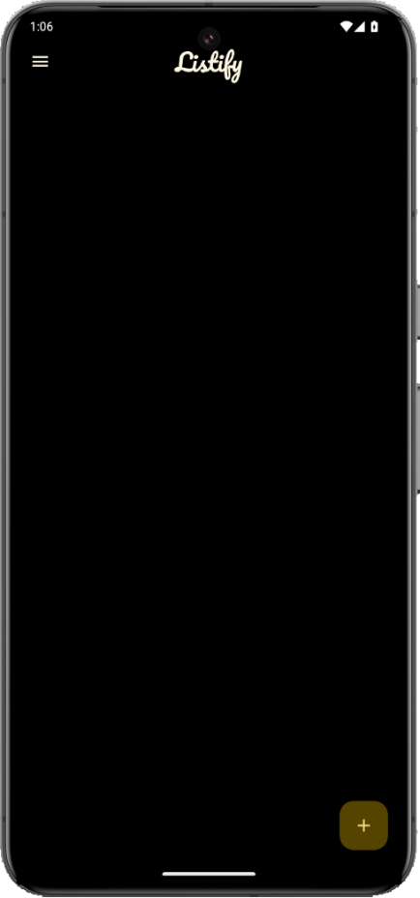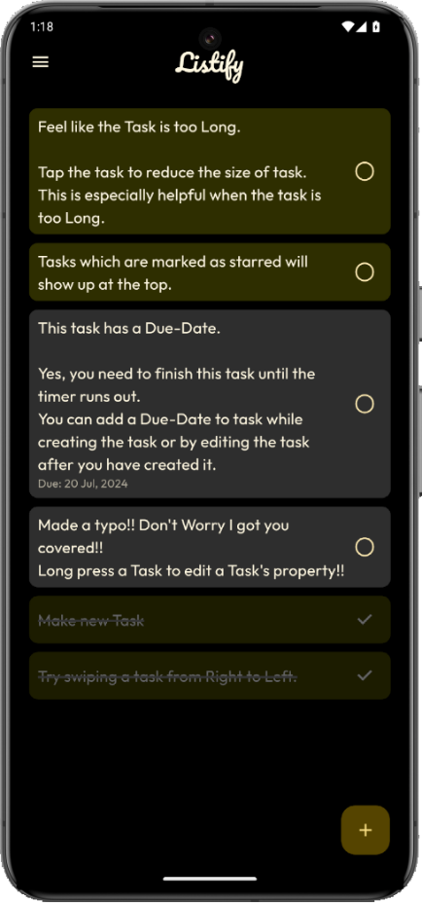Users can easily create, edit or delete tasks from the Homepage.

Fig 4.1 : Application Homepage

### 4.3.2 Task Input And Edit Screen

* Pressing the **‘+’** button at the bottom-right of the Homepage opens up the task input screen.
* From this screen a user can create new tasks.
* To add a due date to a task users can press the calendar icon and select a date accordingly.
* They can also mark a task as important by pressing the star icon.
* Important tasks show up on the top of the list.
* To edit any task which has already been created users will have to press and hold that task and this edit screen will show up.

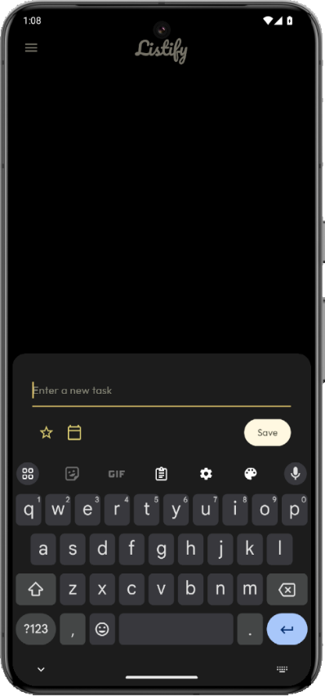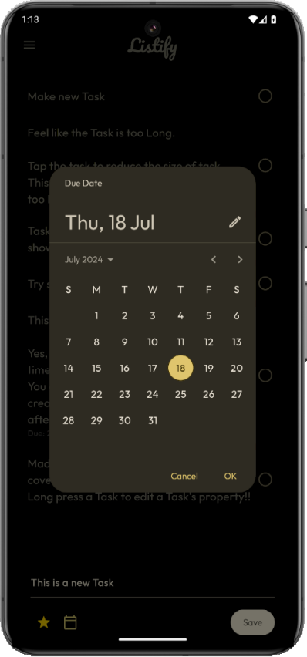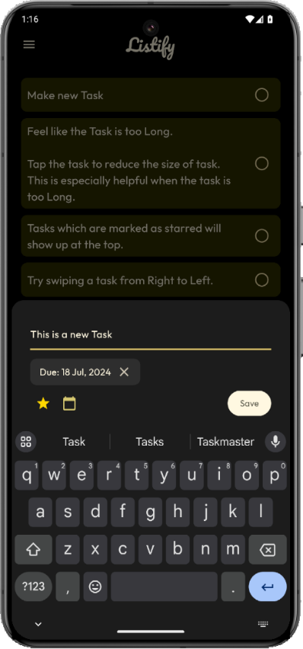

Fig 4.2 : Task Input/Edit Bottom Modal Sheet with a Date Picker

### 4.3.3 Delete Or Mark Task As Important

* Swiping any task from right to left, a Slidable Widget shows up from the right side of the task.
* It has two options:
  + Mark the task as Important.
  + Delete the task permanently from the list.

Fig 4.3 : Mark Tasks as Important or Delete Task by Swiping Left

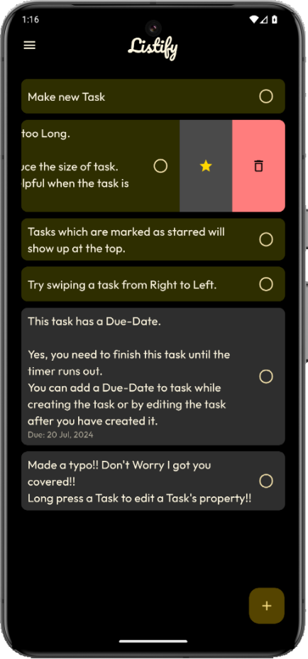

### 4.3.4 Create, Edit Or Delete Multiple Lists

* By pressing the menu icon button on the top-left of the screen, a menu of lists shows up.
* Inside this menu there is a ‘New List’ button at the bottom right of the menu.
* Press this button to create a new list.
* All the list names are unique.
* Any list can be deleted entirely, but beware that deleting a list also deletes all the tasks of the list.
* Edit the list name by tap and holding the list name.

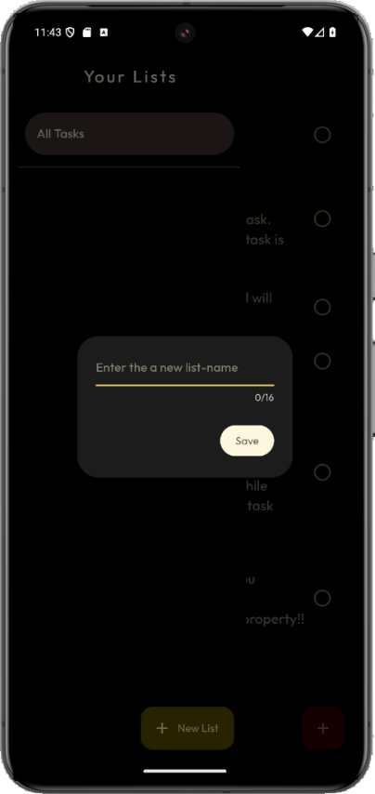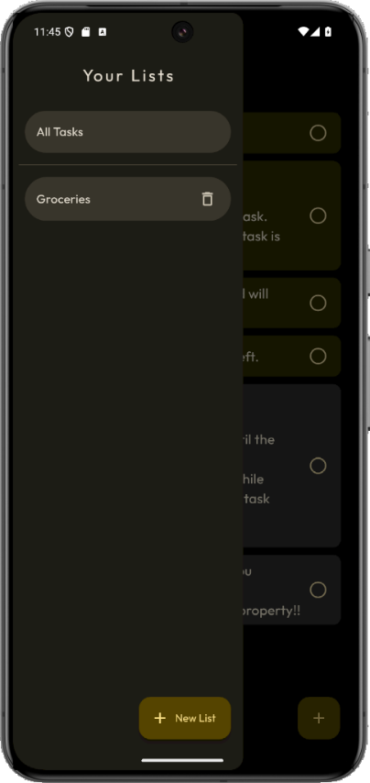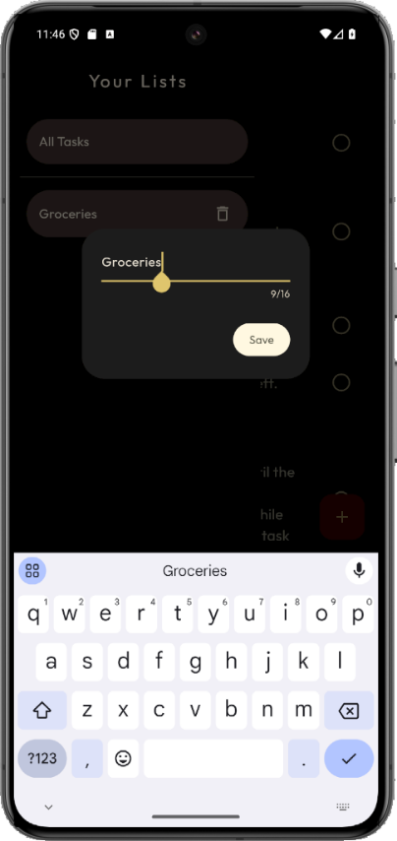

Fig 4.4 : Create, Edit Or Delete Multiple Lists

### 4.3.5 See Tasks Of All Lists In All Tasks Section

* Tasks of all the lists can be seen inside the ‘All Tasks’ section.
* The list name of every task is mentioned inside a label in the task.
* Using ‘All Tasks’ section helps to maintain tasks easily and quickly.
* Changes made to the tasks of other lists from the ‘All Tasks’ section will be reflected in the original list also.

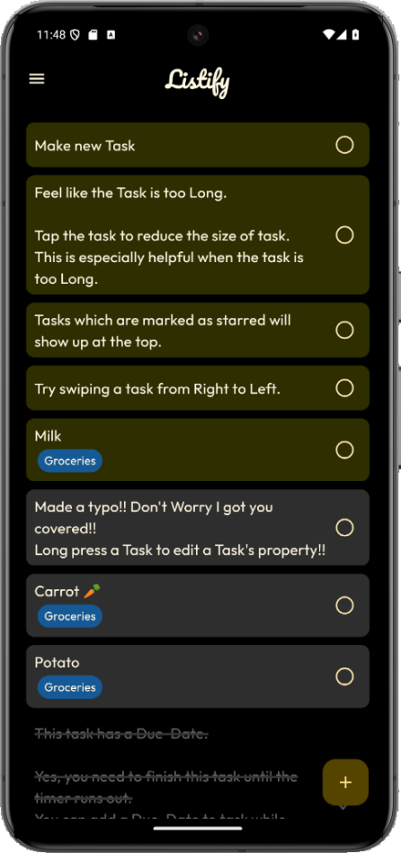

Fig 4.5 : Tasks In All Tasks Section

## 4.4 FUTURE UPGRADES

### 4.4.1 Storing User Data To A Database Using Firebase And Firestore

* Integrate Firebase Authentication to securely manage user sign-in and sign-up processes.
* Utilize Firestore to store and sync user data across devices in real time.
* Implement user-specific data storage to ensure each user's data is kept private and secure.
* Leverage Firestore's querying capabilities to efficiently retrieve and display user data.
* Set up Firestore rules to enhance security and manage access to the data based on user roles.

### 4.4.2 Adding Functionality To Work In Teams Or Groups

* Develop a user interface to allow users to create and join teams or groups.
* Implement real-time synchronization for team-related data, ensuring all members see updates instantly.
* Introduce role-based access control to manage permissions for different team members.
* Enable group messaging and notifications to enhance collaboration within the team.
* Create a dashboard for team activities, providing an overview of ongoing tasks and projects.

### 4.4.3 Assigning Tasks To Team Members

* Add a feature to assign tasks to specific team members, with options for deadlines and priority levels.
* Implement notifications and reminders to ensure team members are aware of their assignments.
* Develop a tracking system to monitor task progress and completion rates for each member.
* Provide an option for team members to update the status of their tasks, offering transparency and accountability.
* Introduce a task reassignment feature, allowing team leaders to reallocate tasks as needed.

### 4.4.4 Creating And Deleting Groups Or Teams

* Design a user-friendly interface for creating new groups or teams, with customizable settings.
* Implement a secure process for deleting groups or teams, ensuring data is properly archived or removed.
* Allow team leaders to manage group membership, including inviting and removing members.
* Provide a group directory for users to easily find and join existing teams that match their interests or projects.
* Ensure data integrity during group creation and deletion to prevent data loss or corruption.

### 4.4.5 Making Someone A Team Leader

* Introduce a role assignment feature, allowing existing leaders to promote members to team leader status.
* Define specific permissions and responsibilities for team leaders to distinguish them from regular members.
* Implement a mechanism for team members to vote or request leadership changes, fostering a democratic process.
* Provide training or onboarding resources for new team leaders to help them understand their roles.
* Ensure team leaders have access to advanced features, such as task reassignment and member management, to facilitate efficient team management.

### 4.4.6 Adding A Login And Signup Page

* Design intuitive and secure login and signup pages with options for email, social media, or phone number authentication.
* Implement form validation and error handling to enhance user experience and prevent incorrect data submission.
* Integrate multi-factor authentication (MFA) for an additional layer of security during login.
* Ensure seamless user onboarding, including welcome messages and quick tutorials for new users.
* • Store user authentication data securely using Firebase Authentication, complying with best practices for data security.

### 4.4.7 Using Cloud Database For Data Security And Better Data Persistence

* Leverage cloud storage solutions like Firebase Cloud Firestore to ensure data is always backed up and available.
* Implement encryption for data at rest and in transit to protect user information from unauthorized access.
* Utilize Firestore's offline capabilities to provide a seamless experience even when the user is offline.
* Set up regular data audits and monitoring to identify and address potential security vulnerabilities.
* Ensure compliance with relevant data protection regulations, such as GDPR or CCPA, to safeguard user privacy.

# CONCLUSION

The development of the Task-Manager-App during my 15-day internship at Navodita Infotech was an invaluable learning experience that significantly enhanced my skills in Flutter Application Development. This project provided me with a comprehensive understanding of the Flutter ecosystem, including hands-on experience with Dart, state management, and data persistence.

Through this project, I gained practical insights into building cross-platform applications, ensuring user-friendly interfaces, and integrating third-party packages to extend app functionality. The challenges I faced, from managing complex state changes to optimizing data storage solutions, allowed me to develop strong problem-solving abilities and a keen eye for detail.

This experience has not only strengthened my technical skills but also deepened my appreciation for the development process, from design to deployment. I am confident that the skills and knowledge I acquired during this internship will be instrumental in my future projects and endeavours in mobile app development.

Overall, this internship has been a pivotal step in my journey as a Flutter developer, equipping me with the tools and confidence to tackle more complex and ambitious projects in the future.

# REFERENCES

* <https://code.visualstudio.com/>
* <https://dart.dev/>
* <https://docs.flutter.dev/>
* <https://github.com/>
* <https://fonts.google.com/>
* <https://pub.dev>